A project by  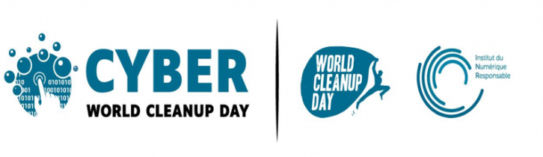 | Supported by

Quantitative grid

Digital Cleanup Day Italy

You can carry out the data clean-up independently from 15 to 20 March 21, then fill in this document and send it to Elena Rangoni Gargano elena.rangonigargano@fraunhofer.it by 20 March 2021 midnight.

It will only take a few minutes to reduce your digital footprint and be part of this transition to a more sustainable digital world.

You will need this document to quantify the data deleted, to do this you will need to collect information on the volume of data freed up before and after the wipe, then we will go on to quantify the positive impact in terms of CO2eq.

CYBERCLEANUP ACTION BUDGET of (1): ______________________________
Company (if you organise the event for a company): ____________________
Number of participants in the operation: _____________________________
Number of items cleaned (2): _______________________________________
Contact person to receive the results (e-mail): __________________________

(1) Name and Surname
(2) E.g. 2 e-mails + 1 smartphone + 1 network drive + 1 PC = 5 items

Write down your efforts:

File type | Number of items ^{(a)} | Data volume ^{(b)}
E-mail
File ^{(c)}
Smartphone e tablet
Social Network
Other files

- Es. 50 e-mail
- Size of deleted items (kilobytes = KB, Megabytes = MB, Gigabytes = GB) Check the total amount of memory before deleting and after deleting to find this value (e.g. 2500 MB)
- After deleting files look at the number in the recycle bin

What did you like about this event:

Points to improve for the next edition:

I authorize the collection of my data by Fraunhofer Italy in accordance with EU Regulation 2016/679 and its processing and storage for the purposes of research related to this questionnaire. This consent is given voluntarily and can be revoked at any time by sending an email to info@fraunhofer.it or by post. I also consent to the processing of my data according to the following privacy policy: https://www.fraunhofer.it/it/informativaprivacy.html

